

School | Lee Kong Chian School of Business
Programme | Master of Quantitative Finance Class 2021
Course Code | QF621 Quantitative Trading Strategies
Instructor | Dr Benjamin Ee
Team Members | Ankit Rawat  Chua Wen Bin  Poh Mei Yi  Sze Tho Kim Ming, Ryan  Wong Boon Fuei, Lawrence  Zhang Chuanyu
Topic | Yield enhancing systematic forex trading strategies & diversification

- Introduction
  - What is Foreign Exchange (FX)?
Foreign Exchange (Forex or FX) market is the biggest global financial market with daily transaction volume exceeding $5 – $6 trillion US Dollars. It facilitates international trade by enabling businesses and economies to perform transactions outside their local currency. Another reason contributing to the huge FX liquidity is that it is treated by some investors as a speculative asset.
Forex trading strategies are the use of specific trading techniques to generate profits from long and short positions in currency pairs. Taking G10 currencies, which consists of USD, EUR, JPY, GBP, CAD, AUD, NZD, CHF, DKK, NOK and SEK, are among the world’s most popular and liquid currencies. Traders can buy or sell them without significantly impacting their exchange rates.
1.2 Objective
The purpose of this project is to discern yield enhanced systematic strategy for forex trading, by comparing the performance of an individual strategy vs a portfolio of strategies. The economic intuition behind this approach is the risk reduction effects achieved through diversification.
1.3 Strategies and construction of the trading signals
For our project, we study the three commonly used systematic strategies in FX market; namely Pairs Trading, Carry Trade and Momentum. These three strategies are replicated using Python programming language and their results are combined to achieve better performance measured using Sharpe Ratio.

- Data Source
Bloomberg data source for G10 FX spot high, low, closing price and 1-month FX Forward end of day closing price (not averaged over a day) to channel as inputs into the trading strategy. EUR, JPY, GBP, CAD, AUD, NZD, CHF, DKK, NOK and SEK represent based currencies (left) against USD as quoted currency (right) All foreign exchange rates are expressed in USD in order to generate a consistent basis for comparison, regardless of their quoting convention. For example, JPY/USD with spot rate of 0.0097 (expressed in USD) as at a specific date.
Interest rates of respective currencies are derived using forward and spot rate based on interest rate parity theory.
Given the high liquidity of the G10 currencies, we estimate a trading cost of 2pips (0.02%) based on the average spreads. Long and short of a particular currency pair simultaneously cost 4 pips spread.
For back-testing purpose, both closing spot rate and 1-month forward rate of all currencies against USD are extracted from Bloomberg for a period of ten years from 1 Jan 2010 to 31 Dec 2020. Below are list of source files extracted from Bloomberg for our back-testing:
- G10_FX_HI_LO_CLOSE.csv
- G10_FX_FORWARD.xlsx
- G10_FX_SPOT.xlsx
3. Individual Strategies
3.1 Pair Trading
3.1.1 Overview
Pairs trading is a form of short-term statistical arbitrage in a forex pair, which enables profiting from any market conditions from a pairs trading correlation.
3.1.2 Strategy construction
This strategy seeks to profit by opening dollar-neutral long and short positions in two currencies with a high correlation, betting on its mean reversion in future. When currency pairs deviate from their historical correlation, we would seek to take a long position in the underperforming currency and/or short the outperforming currency. If the currency pairs return to their historical correlation, a profit is made from the convergence of the prices.
We first determine the cointegration of all G10 currency pairs using over 10 years using cointegration test as shown in heatmap Figure 1 below. Total of 10 most cointegrated pairs that match the criteria of P-Value < 0.1 are selected for pair trading as shown below:
[('EUR', 'CHF'), ('CAD', 'AUD'), ('CAD', 'NOK'), ('CAD', 'SEK'), ('AUD', 'NOK'), ('NZD', 'NOK'), ('NZD', 'SEK'), ('CHF', 'DKK'), ('CHF', 'NOK'), ('CHF', 'SEK')]
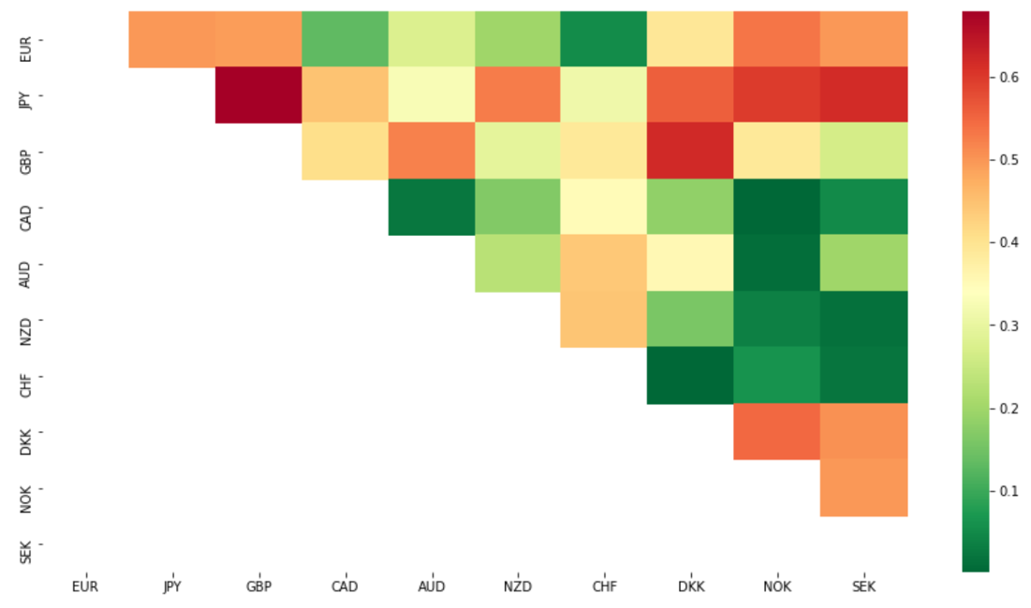
Figure 1: Cointegrated Pairs Heatmap

The strategy encompasses a pair of two different currencies and a ratio is defined. Where the currencies are the sport exchange rate at day t:
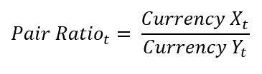
Next, we compute the Z-score as the difference between two periods (5-days and 60-days) of moving average (MA) over 60-days rolling standard deviation (STD) as shown in the formula below:
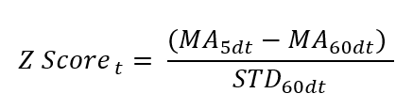
If the Z-Score > 1, we take a long position in Currency X_{t} simultaneously shorting the Pair Ratio_{t} position of Currency Y_{t}, and vice versa if Z-Score < -1. The advantage of starting with a simple rule is that the strategy lends itself to optimization. We close all open positions and take profit if Pair Ratio_{t} is between -0.5 to 0.5.
3.1.3 Performance Results
Pair trading strategy based on 10 currency pairs selected have achieved a cumulative return of 5.63 and Sharpe Ratio of 0.0198 over 10 years. Notable declines in Sharpe Ratio are primarily arising from CHF related pairs. In Sep 2011, Swiss National Bank stunned market by pegging CHF again EUR to prevent its currency strengthened further. The surprise move prompted CHF fall by 8.2% against EUR and 8.8% against USD in a matter of minutes. The subsequent de-pegging in Jan 2015 sent CHF soared by 30% against EUR.
Another worth noting decline in Mar 2020 due to soar in demand for safe-haven currency as Covid-19 situation worsen. These sudden and drastic market events inadvertently disrupt the underlying mean reversion assumption in pair trading strategy.
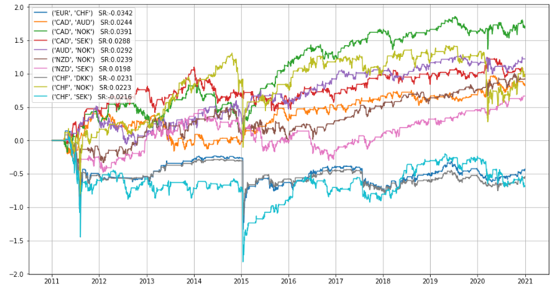
Figure 2: Sharpe Ratio of 10 currency pairs over 10 years
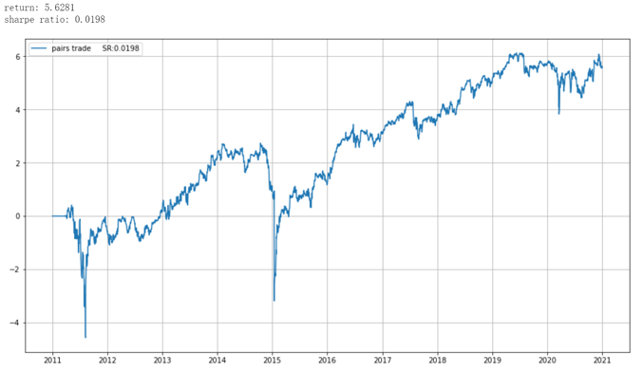
Figure 3: pair trading cumulative return (combined all currency pairs) over 10 years

3.2 Carry Trade
3.2.1 Overview
Carry trade is another popular trading strategy used in the FX market. It involves borrowing a currency that has a lower interest rate (low yield) to fund the purchase of a currency that has a higher interest rate (high yield). Holding this position over the period will result in an interest payment being made to the trader based on the “positive carry” of the trade.
Typically, low interest rate currencies used as funding currencies include Yen and CHF, whereas high interest rate currencies used as lending currencies include AUD, GBP, NZD, etc. The diagram below illustrates how carry trade works:
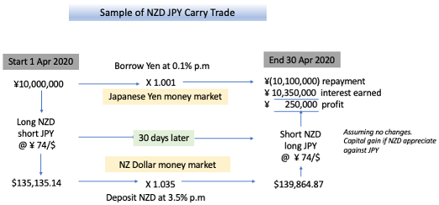
3.2.2 Strategy construction
Uncovered Interest Rate Parity represents the backbone of the carry trade strategy. Interest rate differential (aka forward point) is equal to the differential between the outright forward rate and spot rate as shown in the equation:
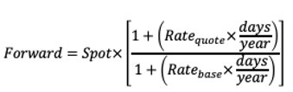
The no arbitrage argument suggests carry trade strategy cannot benefit from interest rate differential without being exposed to currency risk.
The following steps illustrate how carry trade strategy is constructed:
- We form portfolios by sorting at the beginning of each month all currencies according to the value of forward premium (forward rate – spot rate).
- Divide portfolios formed into quantiles. Long portfolio of currencies with the highest forward premium, and short portfolio of currencies with the lowest forward premium.
- Close carry trade position: If the portfolio of currencies returns < 50-quantile AND if market variance > median value, and vice versa.
- Portfolio of currencies are rebalanced monthly.
3.2.3 Performance Results
Overall, carry trade strategy produces relatively low cumulative return of 0.45 and Sharpe Ratio of 0.0176 over 10 years.
Carry trade profits from both positive carry as well as capital gain from strengthening of high-yield currency. Fluctuation in carry trade from 2011 to 2020 as shown in Figure 4 are influenced by ultra-low-rate environment post global financial crisis and European debt crisis at the beginning of our period selected. The subsequent call for quantitative easing tapering followed by US Federal Reserve rate hikes had a profound impact on the interest rates of other G10 currencies as observed from the prolong upward trend from 2017 to 2020.
In late March of 2020, the Sharpe Ratio increased due to strengthening of the USD amid worsening Covid-19 situation. After March 2020, a downward trend in the carry trade cumulative return was observed due to narrowing carrying spread and USD weakening, as central banks worldwide cut rates.
Although carry trade itself has relatively low return and Sharpe Ratio, that doesn’t mean that carry trade is an unfeasible trading strategy. It could have hedging benefits that outweigh its low Sharpe Ratio and be a good choice as part of a larger portfolio of combined strategies.

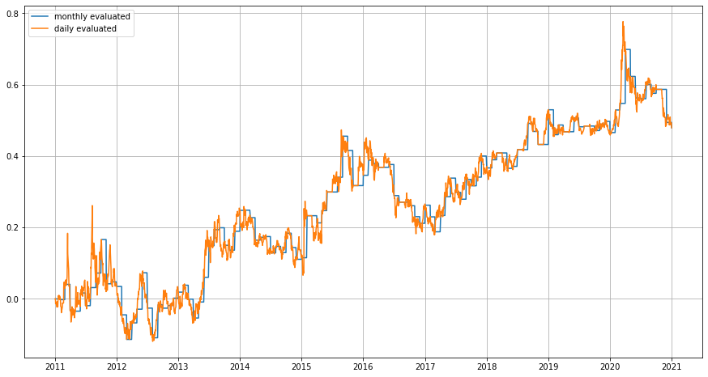
Figure 4: Carry trade cumulative return and monthly rebalancing over 10 years

3.3 Time Series Momentum (TSMOM) Dollar Neutral
3.3.1 Overview
Momentum strategy is a technical trading strategy. Aimed at buying securities that have been showing an upward price trend or short-selling securities that have been showing a downward trend. The main rationale behind momentum investing is that once a trend is well-established, it likely to continue.
This strategy suggests that investors are leveraging the behavioral weaknesses of other investors, such as the tendency to “follow the herd”, also known as the “herd mentality bias”.
3.3.2 Strategy construction
On the first trading day of each month, we calculate each currency’s most recent N -month momentum (N ∈ {1, 3, 12}).
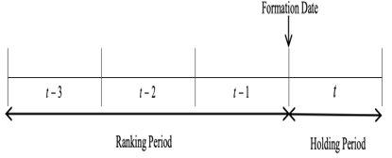
We create dollar-neutral portfolios by going long on the three currencies with the highest momentum and short the futures of the three with the lowest momentum.
Monthly factor performance corresponds to the return of the long portfolio minus the return of the short portfolio. The portfolio is rebalanced at the beginning of each month.
TSMOM strategy, also known as a trend-following strategy, is formed as the average of volatility-scaled long and short positions in a universe of assets.
For this project we had followed “Nick Baltas and Robert Kosowski” paper to generate weights of different FX selected based on TREND earlier.
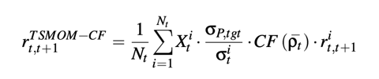
Where X denotes the trading rule that captures the asset’s recent performance over some predetermined lookback period. σtgt denotes a desired volatility target for each individual asset, and Nt is the number of available assets at time t. The volatility of the portfolio is expected to be relatively lower that σtgt due to diversification. CF(ρ¯t)=Correlation factor that adjusts the level of leverage applied to each portfolio constituents at time t.
Weight generated based on mainly three factors - Volatility Estimators, Trading Rules and Pairwise Correlation
Part I: Trading Rule Adjustment (Xit) | Part II: Volatility Estimator | Part III: Correlation Factor (CF)
The SIGN trading rule maps past performance into 􏰅1 without considering the statistical properties and strength of the price path  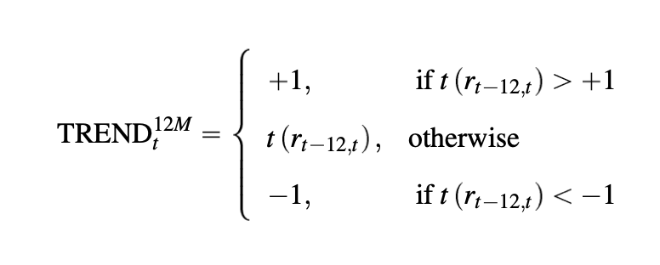 | Asset's volatility as the standard deviation of past close-to-close daily logarithmic returns. The formula of volatility estimator (σYZσYZ) is shown below:  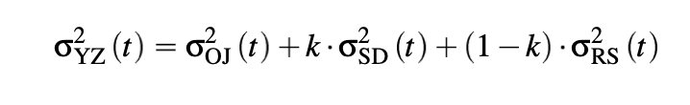  σOJ= SD of close-to-open daily  σSD=standard deviation of close-to-close  σRS= range estimator  k=parameter that minimizes YZ estimator variance  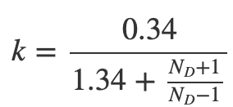 | average pairwise signed correlation of all portfolio constituents. The calculations are shown below:  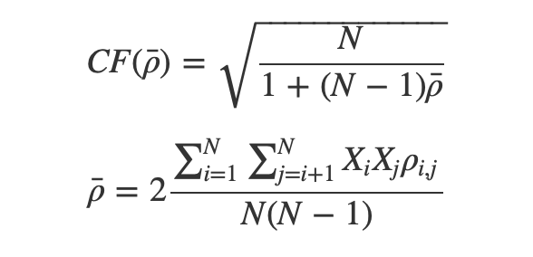 ρi,j=correlation between asset i, jρi,j=correlation between asset i, j  Xi=trade signal of asset iXi=trade signal of asset i  ρ¯=average pairwise signed correlation for the entire portfolio

To form Dollar neutral portfolio we further performed currencies weights Optimization so that Long Buy – Short Sell remains 0.
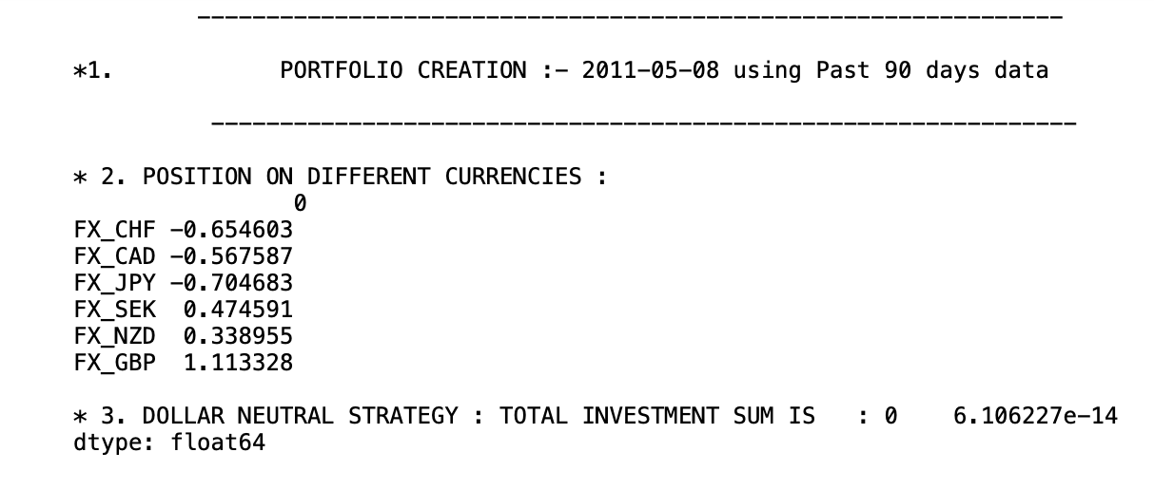
List of constraints:
- To form dollar neutral portfolio, we optimized portfolio keeping total investment amount of long FX – short FX =0
- Rebalancing:
- If expected return is greater than 0, exit from long -short position
- Create position if difference between last position “Position closure date – today’s date” > 20 days
- In a year if no auto rebalancing for a period of 120 days, then exit long -short position
- Below screenshot shows constraints and optimization steps we had taken to achieve dollar neutral portfolio.
- p1,p2,p3,p4,p5,p6 are the list of variable we have used to optimized volatility weights to achieve dollar neutral.
- Variables are range bound and sum of P* volatility weights is zero
- Optimization is to maximize P * Volatility Weight
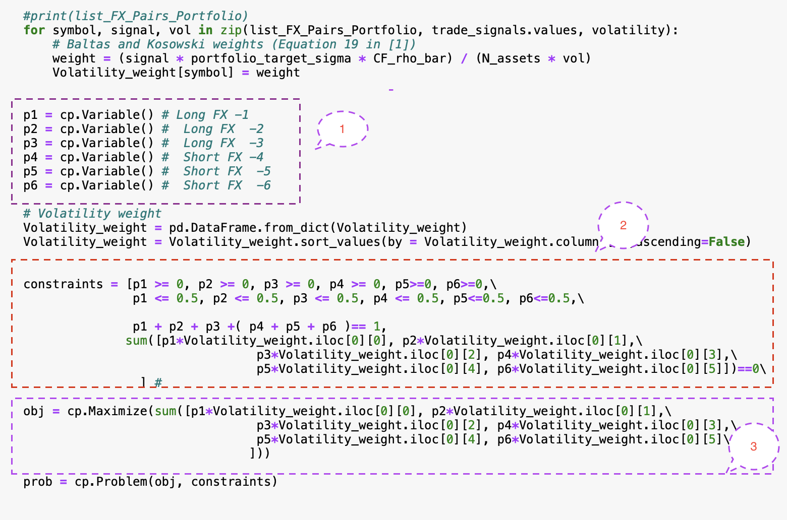
3.3.3 Performance Results
- Portfolio PNL across different years
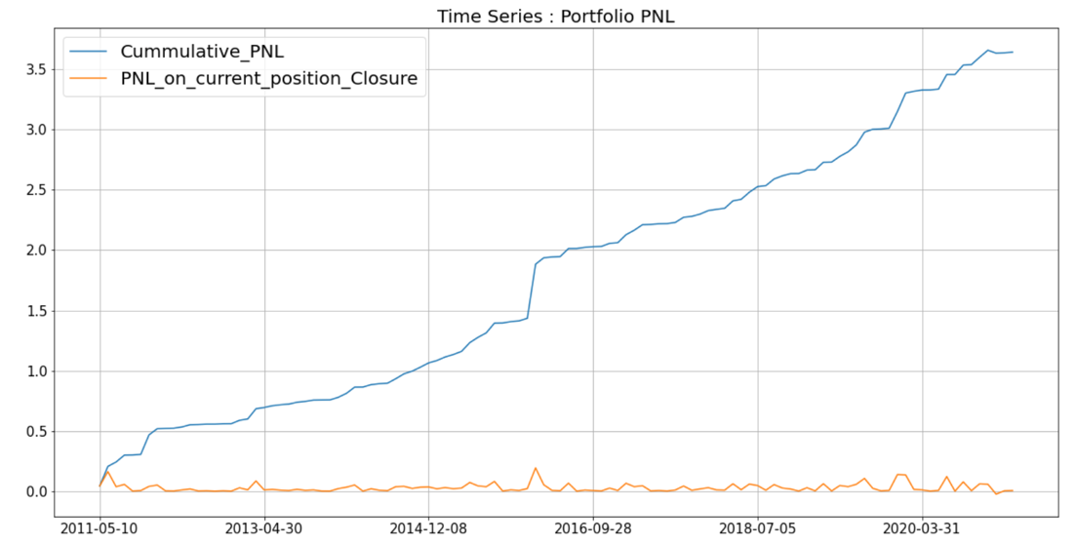
Figure 5: Momentum trade cumulative return and monthly rebalancing over 10 years
- Sharpe Ratio
We observed dip in Sharpe ration below 0.6 in year 2013
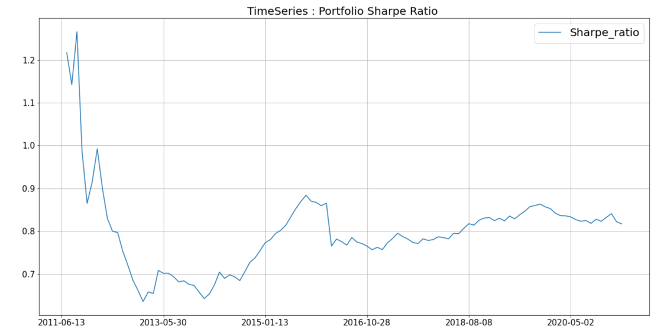
Figure 6: Momentum trade Sharpe Ratio Time Series over 10 years

- Weight Distribution
From the weight distribution, we observed that AUD, EUR, SEK CAD weights has proportionally increased over the years.
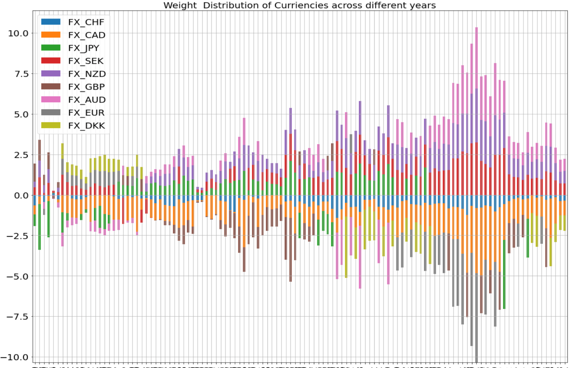
Figure 7: Momentum trade Weight Distribution over 10 years
The Momentum strategy needs frequent rebalancing and over the 10 years we observed AUD has played a significant role in our portfolio along with CAD and EUR. High volatility in market has also attributed towards the impacted portfolio between Sharpe ratio between year 2013 –2015, due to which we saw a decline in Sharpe ratio during the given period. Overall, we see Momentum strategy as a profit-making strategy as most of the times we had positive PNL during the 10 years horizon.

- Portfolio Combination Strategies
4.1 Back-test performance and findings
Having constructed the above individual FX strategies, we identified the decision to combine them in order to test our strategy hypothesis of enhancing yield from diversification across the 10 years period. The weightage for the three strategies are normalized using their respective volatilities. Factoring in a transaction fee of 2pips (0.02%), based on the observed spread.
The results of the risk-weighted combined strategy are below:
Strategy | Pairs | Carry | Momentum | Combined
Sharpe Ratio (SR) | 0.019 | 0.018 | 0.807 | 1.432
Mean return | 5.628 | 0.450 | 3.642 | 2.447
Table 1: Strategy Results Sharpe Ratio & Mean Returns
4.2 Economic intuition
As we can see from the table above, the combined strategy outperforms the individual strategies’ Sharpe Ratio (SR), with disproportionate results that are more than the sum of its parts. This is testament to the effects of diversification for enhanced yield from a basket of three popular FX trading strategies.
Particularly, there are interesting strategy pairs that foreshadow the intuition behind diversification enhanced yield. These are as follows:
- Pairs and Carry trade provide higher yield (SR of 1.151) due in part to the lower volatility induced by the carry trade, given the downtrend in the interest rate environment across 10 years. The carry strategy could have hedging benefits that outweigh its low individual SR and be a good choice as part of a larger portfolio of combined strategies.
- Pairs and Momentum is another strategy pair with an inherent economic intuition backing the diversification rationale. The idea is that when one strategy is making money, the other will lose but at a lower rate, so it is still net positive. In addition, mean reversion strategies are correct very often but with a lower yield when so. Momentum strategies are correct occasionally but with huge yields when they are, and with stop losses in place, will lose a little when the momentum strategy is wrong.
A portfolio of these two strategies will oscillate between a range bound and a trending regime, such that the mean reversion generates yield during the range bound regime (momentum should lose but lose less than that for which the mean reversion is making). Vice versa, during the trend regime, momentum will enhance yield significantly, at rates higher than mean reversion will lose.

5. Conclusion
Based on our model, it is clear, that a risk-weighted combined portfolio of three strategies (Pairs, Carry, Momentum) generates the highest yield. The comparison of the Sharpe Ratios, as back tested across a time range of 10 years, provides consistent results to our original diversification hypothesis (per table below).
The economic intuition backing this result, as exposited in section 4.2, is one that amplifies the age-old adage of diversification for FX systematic trading, when carried out right.
Strategy | Pairs | Carry | Momentum | Combined
Sharpe Ratio (SR) | 0.019 | 0.018 | 0.807 | 1.432
Table 2: Combined Results Conclusion

